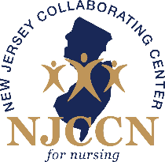

Clinical Coordinator Meeting
Agenda

December 17, 2020
9:00 – 10:00 AM

- Minutes

- Update on new residents

- Coordinator presentation TBD

- Status with COVID-19

- Vizient updates

- Open Forum

